
Application of central composite design for optimization of the removal of humic substances using coconut copra

The objective of this research paper is to evaluate the optimum conditions for the removal of humic substances from peat swamp runoff using modified coconut copra by applying Design of experiments (DoE) methodology.
The factors (independent variables) examined are: X₁ = dosage (g), X₂ = contact time (min) and X₃ = temperature (ºC). All the factors are continuous. The response (dependent variable) examined is: Y = removal efficiency (%). The applied DoE method is Inscribed Central Composite design.
Isalos version used: 2.0.6
Scientific article: https://link.springer.com/article/10.1007/s40090-015-0041-0

Step 1: Central Composite Design
In the first tab named “Action” define the factors in the column headers and fill each column with the low and high levels of the corresponding factors. This tab can be renamed “CCI”. Afterwards, apply the Inscribed Central Composite method: DOE $→$ Response Surface $→$ Central Composite
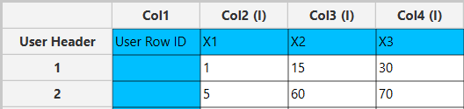
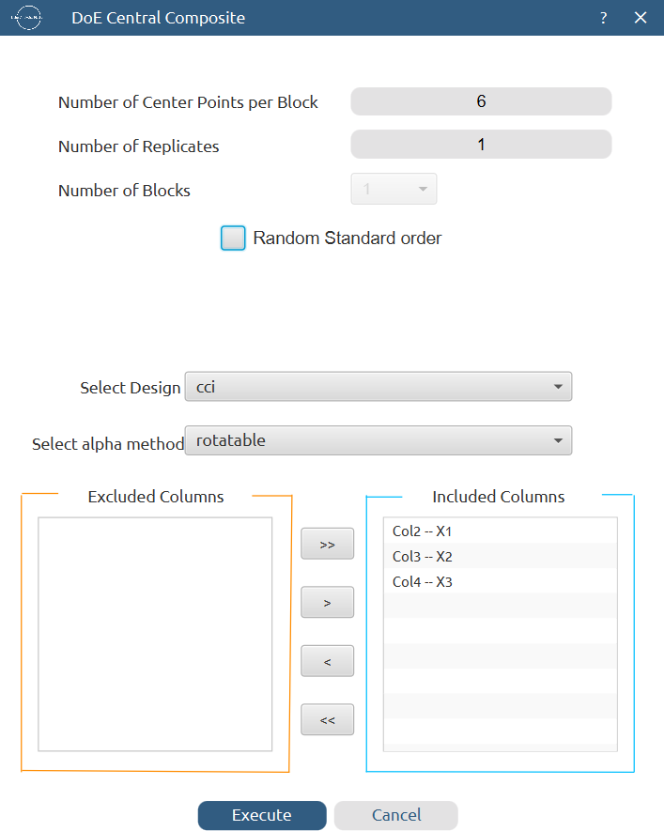
Results (right spreadsheet):
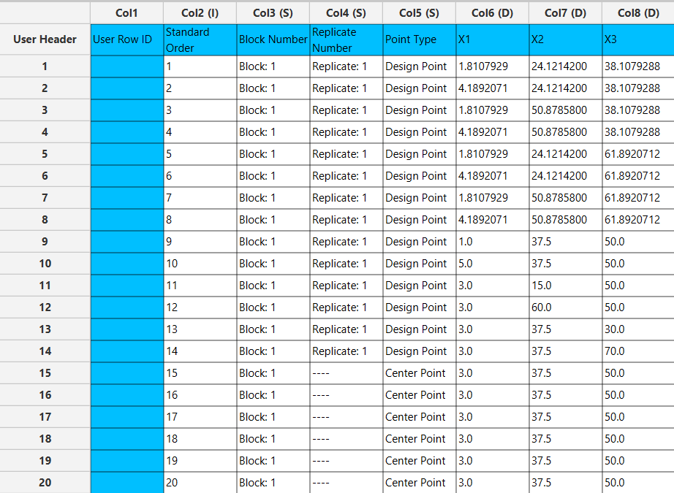

Step 2: Definition of response variables
Create a new tab named “Responses” and define the responses in the column headers. Fill each column with the values of the corresponding responses that were observed and make sure the values follow the order of the experiments as given by the Inscribed Central Composite method. Then, select all columns to be transferred to the right spreadsheet: Data Transformation $→$ Data Manipulation $→$ Select Column(s)

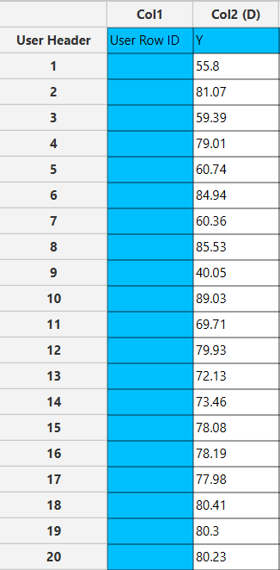
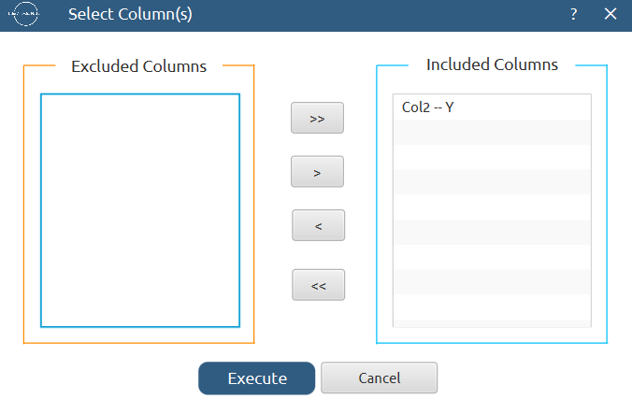

Step 3: Data isolation
Create a new tab named “Data” and import the results from the “CCI” and “Responses” spreadsheets by right clicking on the left spreadsheet. Then, select only the factors and responses columns to be transferred to the right spreadsheet: Data Transformation $→$ Data Manipulation $→$ Select Column(s)

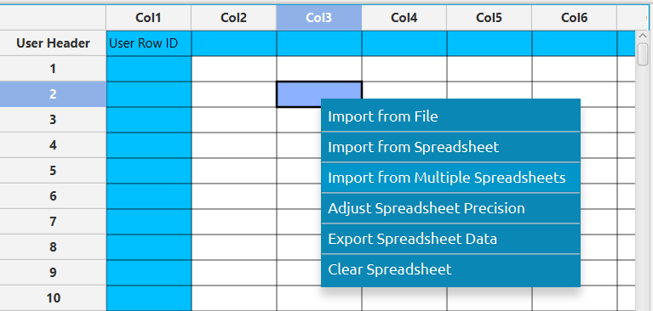

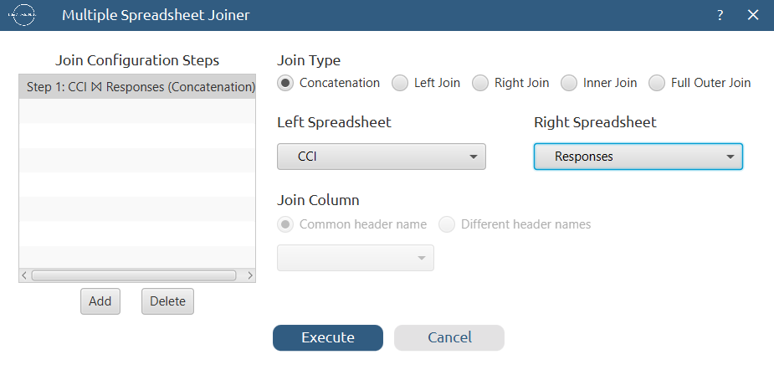

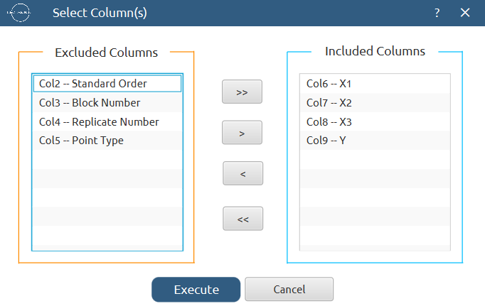

Results:
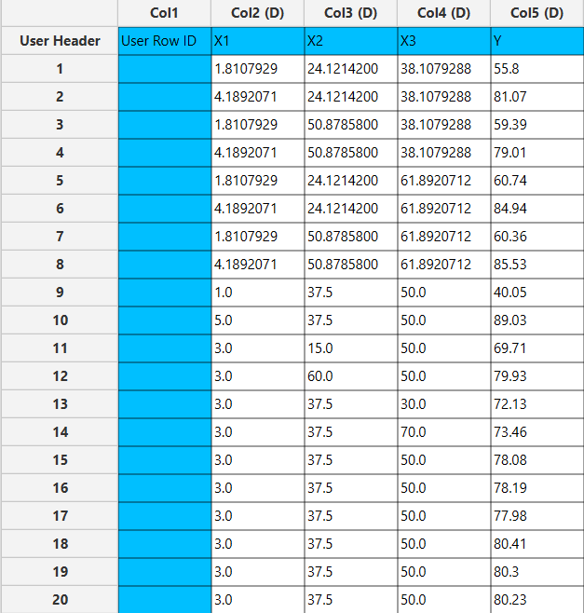

Step 4: Normalization
Create a new tab named “Normalized data” and import the results from the “Data” spreadsheet. Afterwards, normalize the factor columns to take values in the range [-1, 1]: Data Transformation $→$ Normalizers $→$ Min-Max



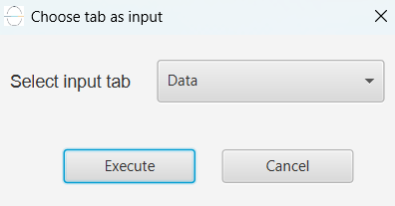

Results:
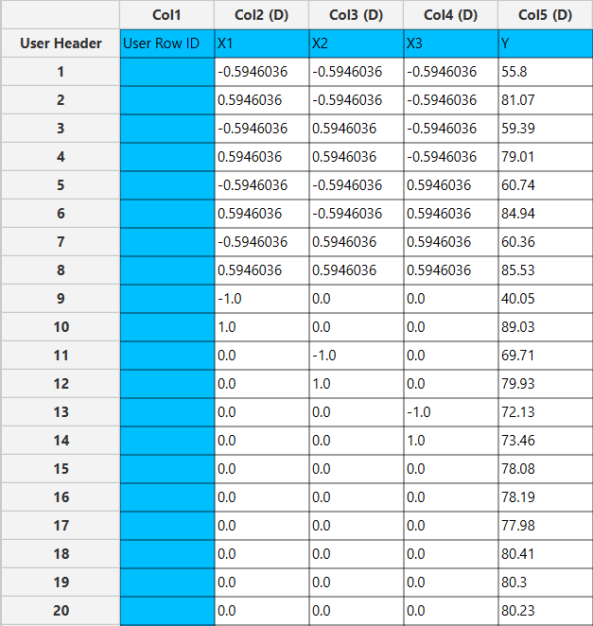

Step 5: Regression – Linear
The goal here is to produce a regression equation that includes only the main effects for the response variable Y: $Y=b_{0}+b_{1}X_{1}+b_{2}X_{2}+b_{3}X_{3}$
Create a new tab named “Regression – Linear” and import the results from the spreadsheet “Normalized data”. Afterwards, fit a generalized linear model to the data: Analytics $→$ Regression $→$ Statistical fitting $→$ Generalized Linear Models

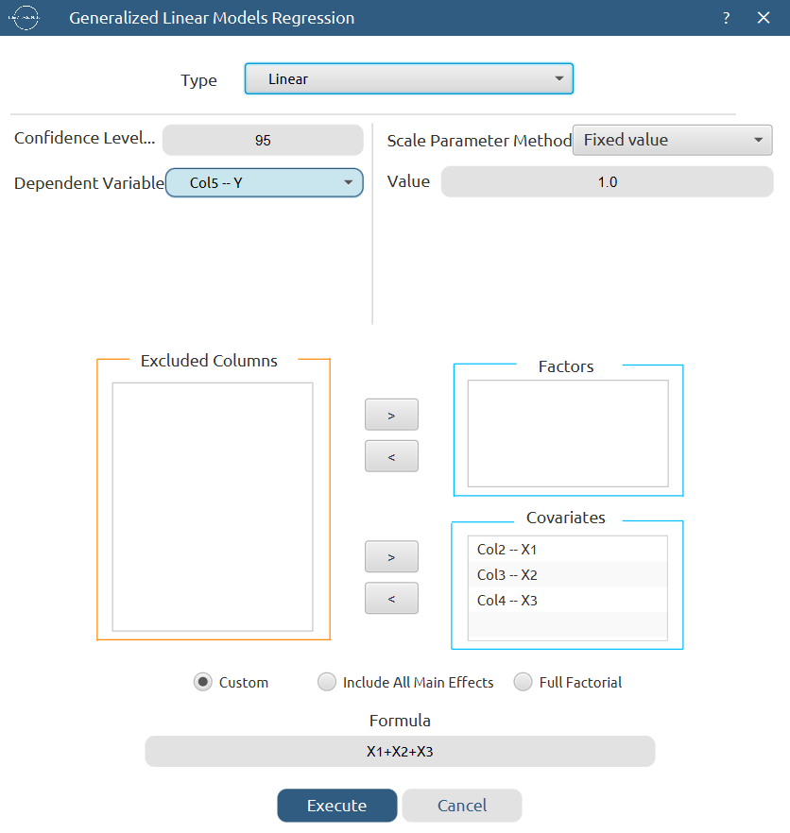

Results:

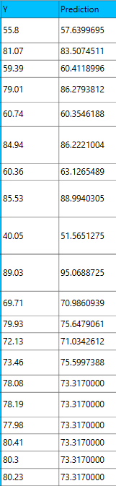
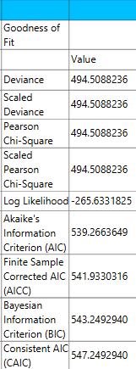

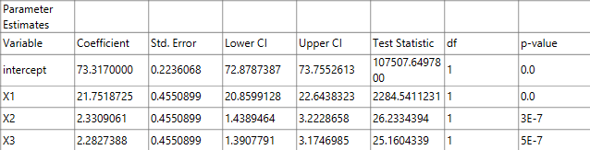

Step 6: Regression – Interactions
The goal here is to produce a regression equation that includes main effects and two-factor interactions for the response variable Y:
$$Y=b_{0}+b_{1}X_{1}+b_{2}X_{2}+b_{3}X_{3}+b_{12}X_{1}X_{2}+b_{13}X_{1}X_{3}+b_{23}X_{2}X_{3}$$

Create a new tab named “Regression – Int” and import the results from the spreadsheet “Normalized data”. Afterwards, fit a generalized linear model to the data: Analytics $→$ Regression $→$ Statistical fitting $→$ Generalized Linear Models

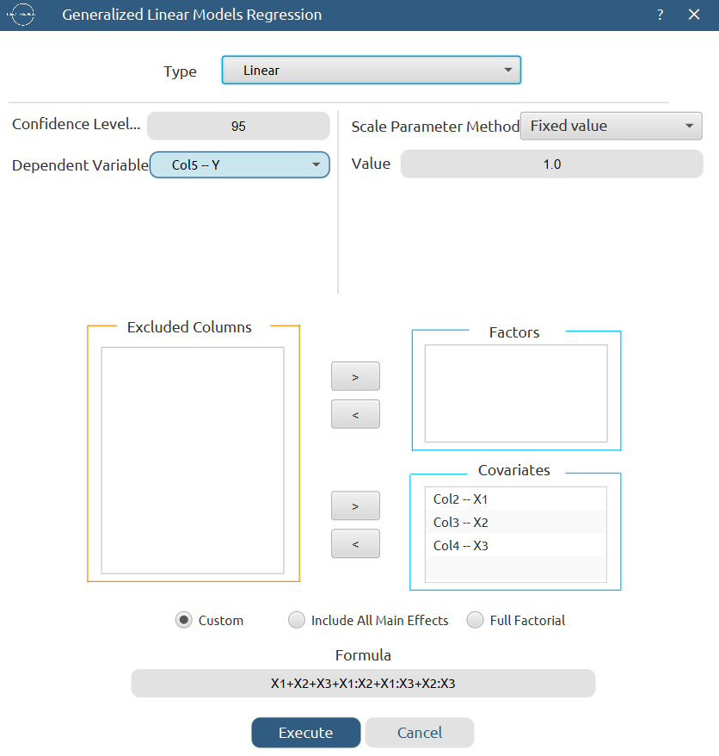

Results:
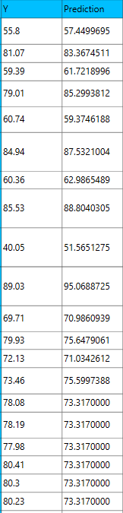
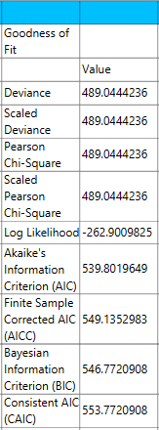

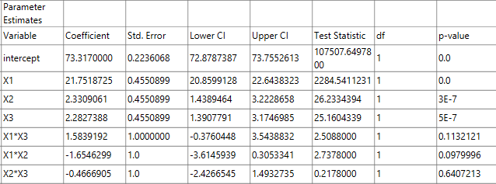

Step 7: Regression – Quadratic
The goal here is to produce a regression equation that includes main effects, two-factor interactions and quadratic effects for the response variable Y:
$$Y=b_{0}+b_{1}X_{1}+b_{2}X_{2}+b_{3}X_{3}+b_{12}X_{1}X_{2}+b_{13}X_{1}X_{3}+b_{23}X_{2}X_{3}+b_{11}{X_{1}}^{2}+b_{22}{X_{2}}^{2}+b_{33}{X_{3}}^{2}$$

Create a new tab named “Regression – Quad” and import the results from the spreadsheet “Normalized data”. Afterwards, fit a generalized linear model to the data: Analytics $→$ Regression $→$ Statistical fitting $→$ Generalized Linear Models

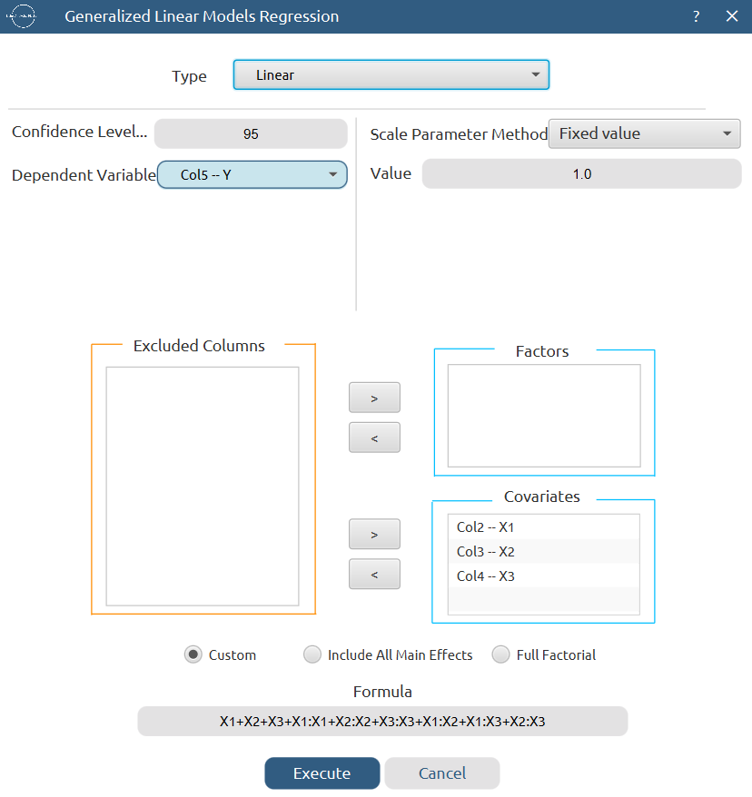

Results:

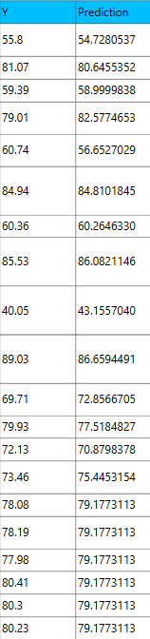
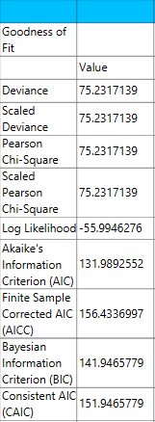

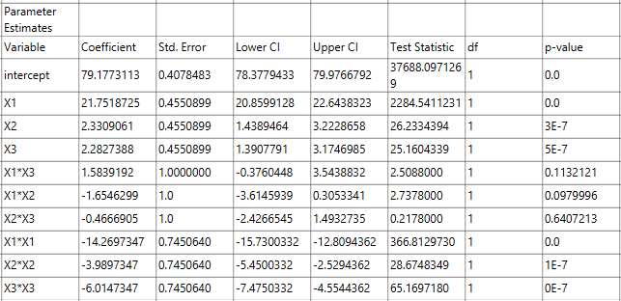

Step 8: Regression Metrics
Create a tab named “Metrics – Linear” and import the results from the spreadsheet “Regression – Linear”. Then, produce the regression metrics for the linear regression equation: Statistics $→$ Model Metrics $→$ Regression Metrics

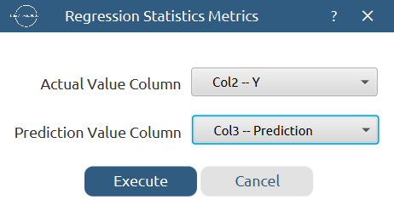

Results:
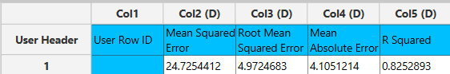

Repeat this step for the interactions and quadratic regression equations. Results:
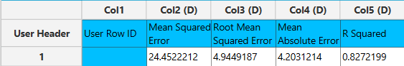

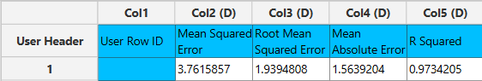

Step 9: Analysis of Covariance
Create a new tab named “ANCOVA – Quad” and import the results from the spreadsheet “Normalized data”. Afterwards perform analysis of covariance for Y using the formula for the quadratic equation: Statistics $→$ Analysis of (Co)Variance $→$ ANCOVA

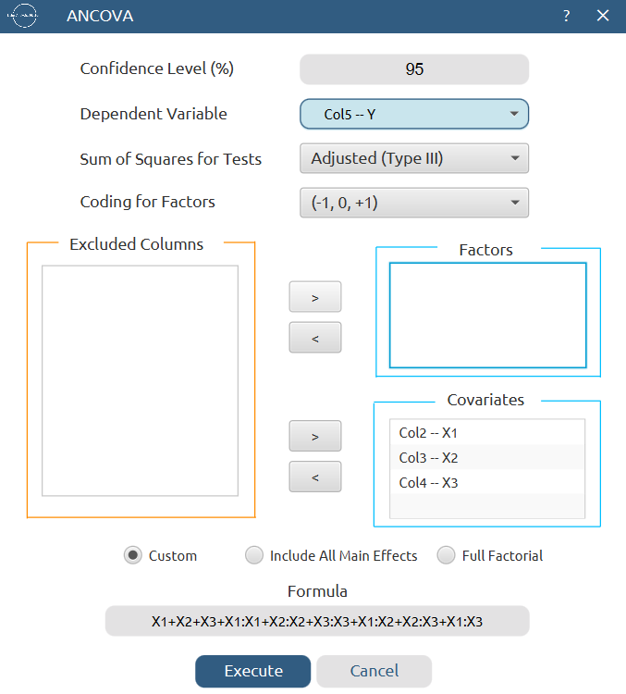

Results:
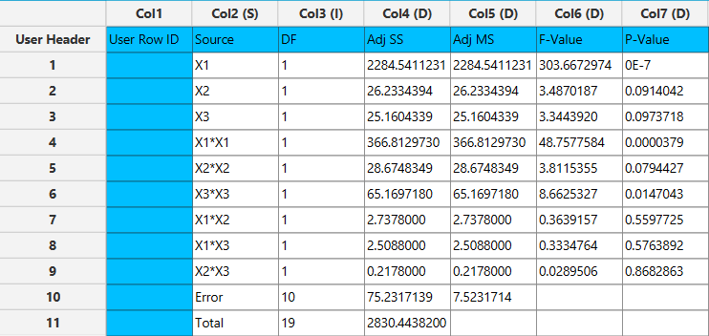

Final Isalos Workflow
The final workflow is presented below:
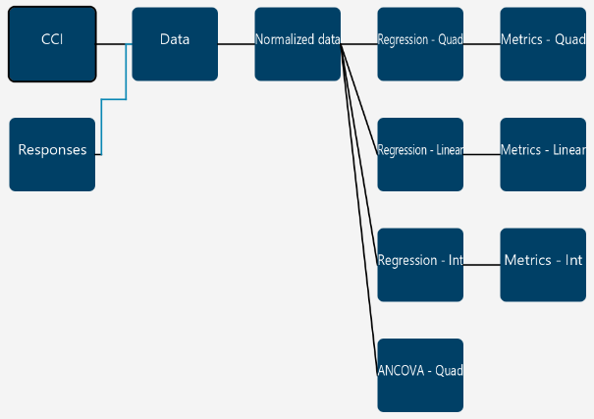

References
- Lee, T. Z. E.; Krongchai, C.; Mohd Irwn Lu, N. A. L.; Kittiwachana, S.; Sim, S. F. Application of Central Composite Design for Optimization of the Removal of Humic Substances Using Coconut Copra. Int J Ind Chem 2015, 6 (3), 185–191. https://doi.org/10.1007/s40090-015-0041-0.

